

**UNIVERSITY INSTITUTE OF ENGINEERING**

**Department of Computer Science & Engineering**

# Subject Name: DATA MINING LAB

**Subject Code:** 20CSP-376

**Submitted to: Submitted by:**

Faculty name: Er. Himanshi Name: Sahil Kaundal

UID: 21BCS8197

Section: 616

Group: A

**INDEX**

|  |  |  |  |  |  |  |
| --- | --- | --- | --- | --- | --- | --- |
| **Ex. No** | **List of Experiments** | **Conduct (MM: 12)** | **Viva**  **(MM: 10)** | **Record (MM: 8)** | **Total**  **(MM: 30)** | **Remarks/Signature** |
| 1 | Demonstration of preprocessing on .arff file using student data. arff |  |  |  |  |  |
| 2 |  |  |  |  |  |  |
| 3 |  |  |  |  |  |  |
| 4 |  |  |  |  |  |  |
| 5 |  |  |  |  |  |  |
| 6 |  |  |  |  |  |  |
| 7 |  |  |  |  |  |  |
| 8 |  |  |  |  |  |  |
| 9 |  |  |  |  |  |  |
| 10 |  |  |  |  |  |  |

**Experiment 1**

**Student Name:** Sahil Kaundal **UID:** 21BCS8197

**Branch:** CSE (Lateral Entry)  **Section/Group:** 616/A

**Semester:** 6th **Date of Performance:** 28/02/2023

**Subject Name:** Data Mining Lab **Subject Code:** 20CSP-376

1. **Aim:**

Demonstration of preprocessing on .arff file using student data. arff.

1. **Apparatus / Simulation Used:**

To represent the creation of file using R Studio and displaying the pattern on Weka Tool for further extraction and analysis of knowledge.

1. **Objective:**

* Windows 7 or above.
* R Studio.

1. **Script and Output:**

library(RWeka)

setwd("F:/Rcodes")

getwd()

Rating <- 1:4

Animal<-c('Kaola','Panda','Dog','Cat')

Country<-c('India','Sri Lanka','Australia','Japan')

Avg.sleepers<- c(21,18,17,10)

super_sleepers<- data.frame(Rating,Animal,Country,Avg.sleepers, stringsAsFactors = FALSE)

print(super_sleepers)

print(class(super_sleepers))

print(str(super_sleepers))

write.arff(super_sleepers,file="super_sleeper.arff")

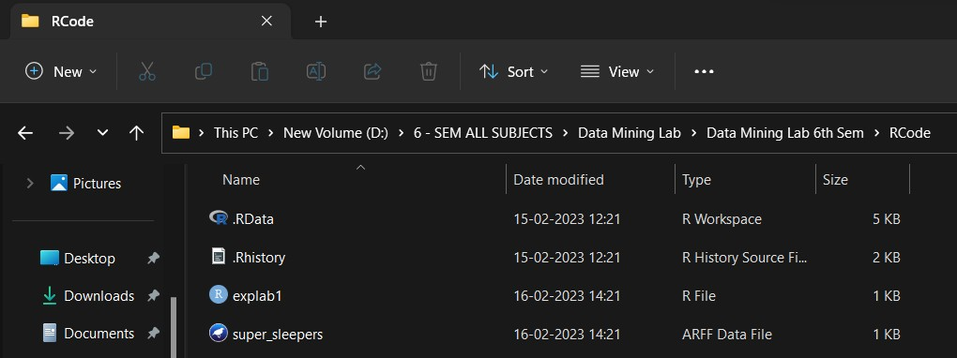

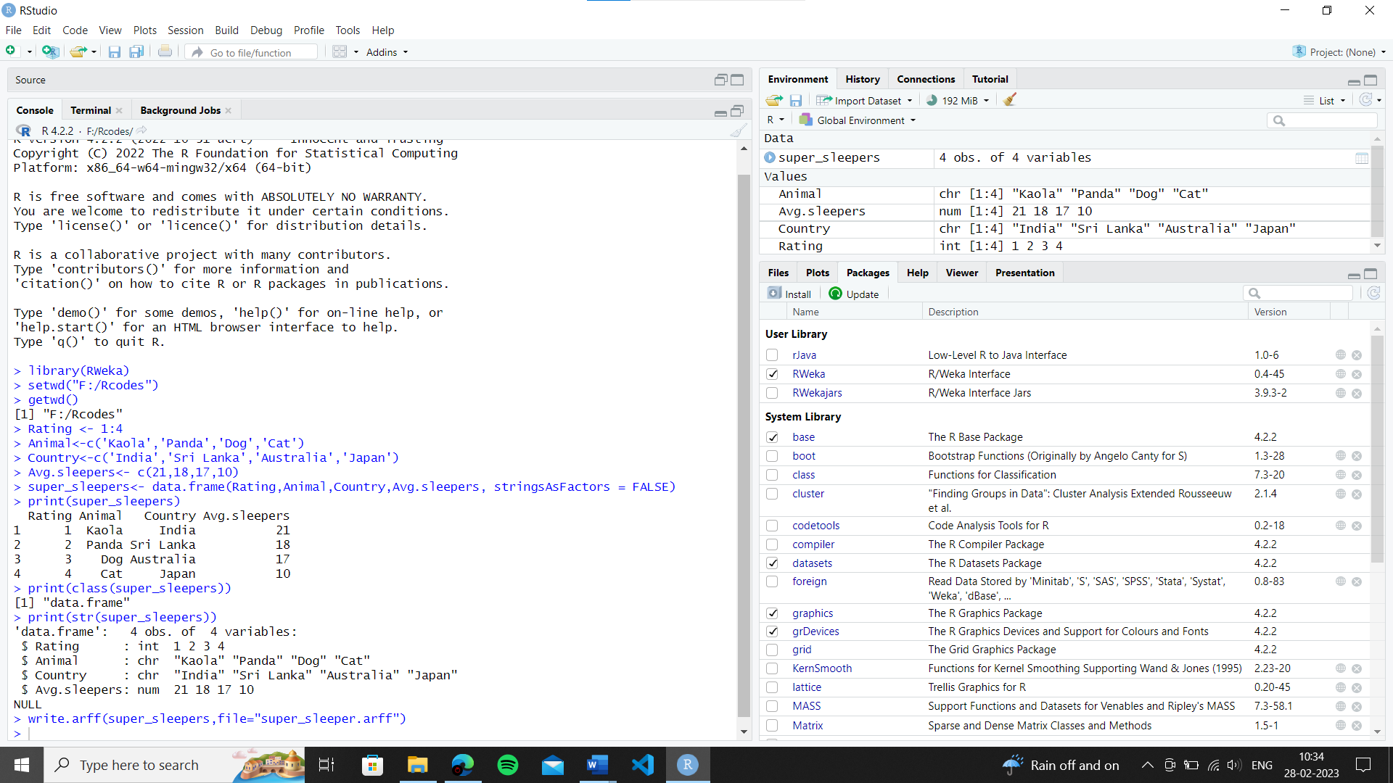

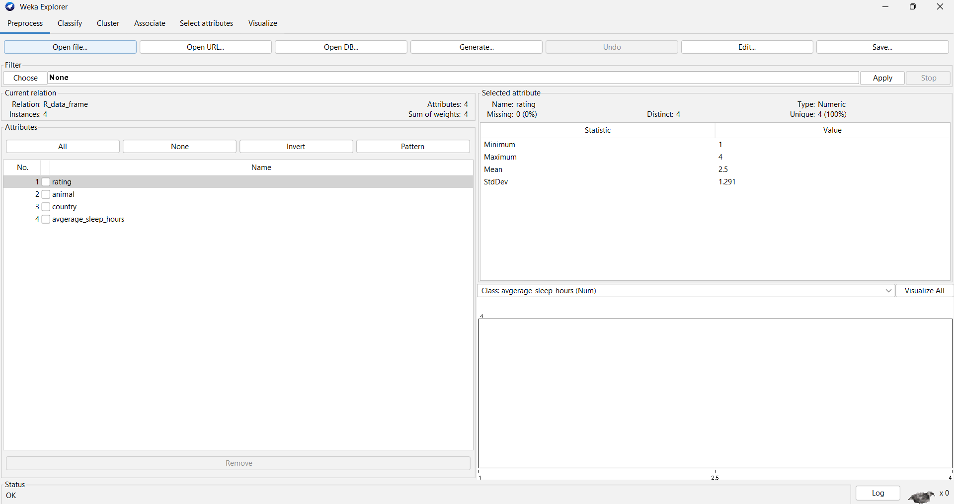

**Learning outcomes (What I have learnt):**

* Learnt about RStudio.
* Learnt about ARFF files and how to create ARFF File.

**Evaluation Grid (To be created as per the SOP and Assessment guidelines by the faculty):**

|  |  |  |  |
| --- | --- | --- | --- |
| Sr. No. | Parameters | Marks Obtained | Maximum Marks |
| 1. |  |  |  |